Title in bold and centered in 14 pt Times New Roman
as in this title

Name Surname¹, Name Surname² , Name Surname³
¹Affiliation, address
²Affiliation, address
³Affiliation, address

The title of abstract should be in 14pt. with a fixed line spacing of 14pt. Leave a blank line after the title and then enter the names of the author(s), in 12 pt, each followed by a comma and numbers for reference to each author’s affiliation. If not the first author presents the work, please, indicate the presenting author by underlining his/her name. Then enter the affiliations, in 12 pt. italic, each on a separate line. Enter another blank line before the beginning of the text of the abstract.
All abstracts must be written in English and occupy a maximum of two A4 pages written in Times New Roman 12 pt, single spacing. Its size cannot exceed 512kB.
Leave a blank line between each paragraph titled as

Introduction

Materials and Methods
Please, keep it simple!

Results
Figures & tables should be embedded in text and referred to in the text with the proper numbering. You can send figures in color or greyscale.

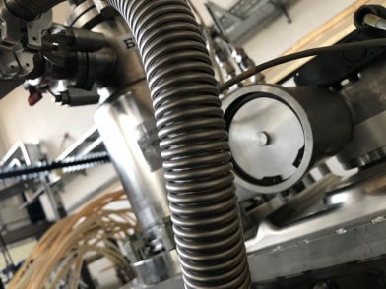
Figure 1. The style to be used for graphs.

The resoultion of the figures should be as high as possible (at least 300dpi).
Captions should be in 11 pt., centered together with figures/tables and positioned below for figures, and above for tables.

Table 1. The style to be used for tables.
Head1 | Head2 | Head3 | Head4 | Head5 | Head6
Col1 | Col2 | Col3 | Col4 | Col5 | Col5
Col1 | Col2 | Col3 | Col4 | Col5 | Col5
Col1 | Col2 | Col3 | Col4 | Col5 | Col5

Conclusion
Do not indent the paragraphs. The text should be justified left and right. Literature should be referenced in [ref. number] format, with references listed in the end (see below). Equations should be given in separate line and numbered only if they are referenced elsewhere in the text, too.
Please, submit abstract in .docx format (up to 512kB)
Please, name your abstract file using the first author’s name, indicating the research area in the following format:
surname_initials_materials.docx
surname_initials_lifesci.docx

If the same first author is submitting more than one abstract, please use surname_initials_1.docx, surname_initials_2., etc.

References
[1] Y. E. Kalay, Y.Kuru, E. Unalan, Int. J Hydrogen Energy, 12 (2015) 915–920

